Eastern Cascades Glaciated Plateaus
Overall Terrain:
Plateaus in the Pacific Northwest are predominantly underlain by stacked flows of the Columbia River Basalts and form extensive elevated plains bounded on one or more sides by steep slopes hundreds of feet above adjoining areas. Plateaus are differentiated from each other by the most-evident surficial processes of alteration.

Landform Association:
Glaciated Plateaus:

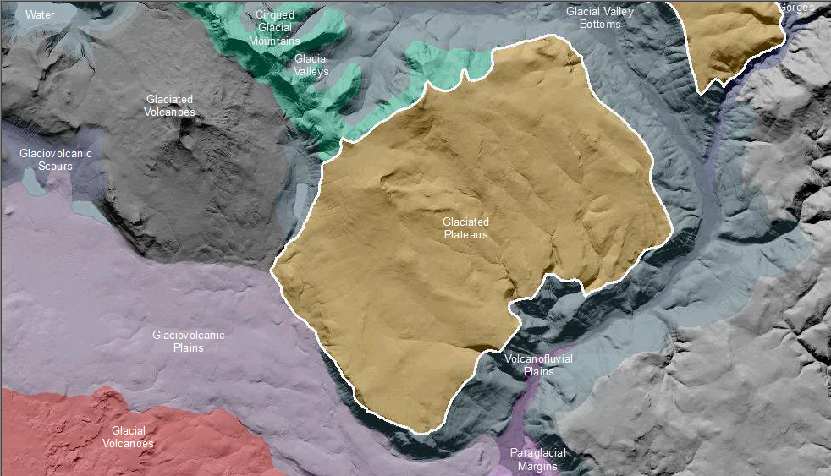

Glaciated Plateaus are Plateaus with masked glaciation or nivation features from past alpine glacial activity moving across an existing plateau landscape. Nivation features, including shallow bowls and arcuate headwalls were created by erosion of the ground beneath and around snowbanks and permanent ice fields mainly as a result of freeze-thaw and ice plucking. Much of the signature of glaciation is masked as a result of erosional and weathering processes over time.

This Landform Association has a limited spatial extent on National Forest System Lands.

Landtype Associations: Landtype Associations are formed by intersecting vegetation series or groups of vegetation series with Landform Associations.

Topography:
The following tables represent the average conditions for the Landform Association. Only lands within and adjacent to National Forest System Lands were mapped by this project. The entire EPA Level III Ecoregion is not covered by this mapping.

The percent of Landform Association (% of LfA) in bold in the table below refers to the percent of the Ecoregion represented by that Landform Association. The (% of LfA) numbers not in bold in the table below refer to the percent of each Landtype Association within the Landform Association.
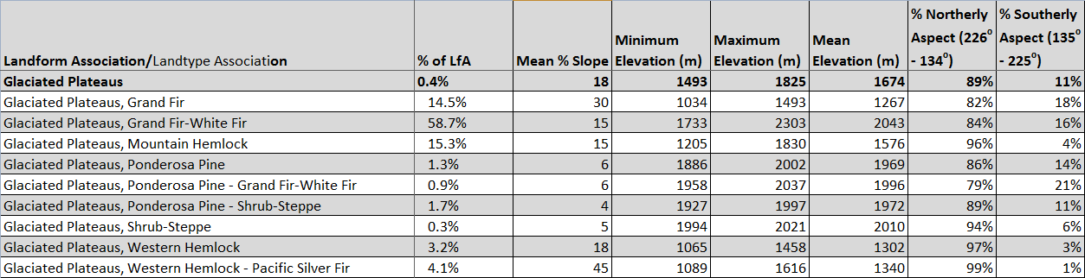

Climate:
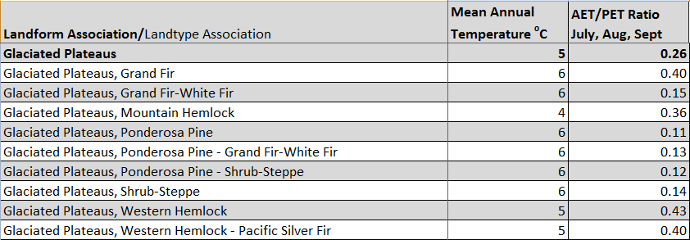

The ratio of Actual Evapotranspiration to Potential Evapotranspiration (AET/PET) is used as a broad-scale indicator of potential drought stress. We obtained modeled actual and potential evapotranspiration datasets from the Numerical Terradynamic Simulation Group at the University of Montana (http://www.ntsg.umt.edu/project/mod16) for a 30 year climate average. AET/PET ratio in the table above is based on a scale of zero to one. A value closer to 1 means the vegetation is transpiring close to its potential. A value farther from 1means that the Actual Evapotranspiration is below potential based on this climatic zone (Ringo, et. al. 2016 in draft).

