Eastern Cascades Fluviolacustrine Deltas
Valley [Landscape Term] (a) Any low-lying land bordered by higher ground; esp. an elongate, relatively large, gently sloping depression of the Earth's surface, commonly situated between two mountains or between ranges of hills or mountains, and often containing a stream with an outlet. It is usually developed by stream erosion, but may be formed by faulting. (b) A broad area of generally flat land extending inland for a considerable distance, drained or watered by a large river and its tributaries; a river basin. (Bates and Jackson, 1995)

Landform Association: Fluviolacustrine Deltas
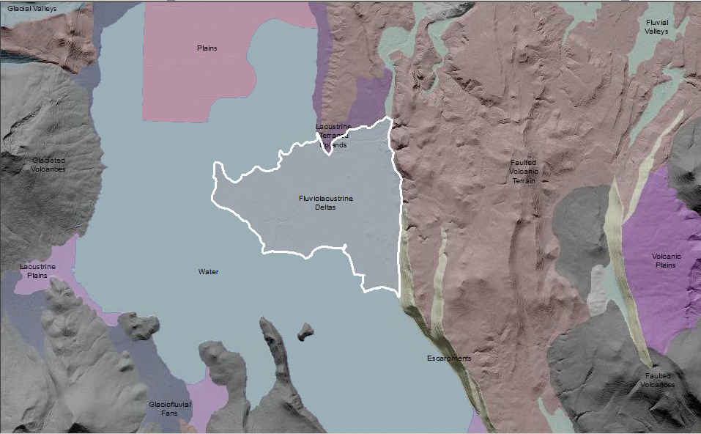

Fluviolacustrine Deltas form where river systems deposit into a lake. Deltas are low, nearly flat, alluvial tract of land at our near the mouth of a river, commonly forming a triangular or fan-shaped plain of considerable area, crossed by many distributaries of the main river. Most deltas are party subaerial and partly below water (BJ 1995, FS Geomorph). Fluviolacustrine Deltas are complex landforms due to the varying lake levels into which they are deposited. The particle size deposited varies by what the river system is transporting. Once in the lake, sediments are sorted with the coarser particles in the channels and the finer particles in the levees. These sediments mix with the organic-rich diatomateous earth and fine particles that form the lake substrates. Soils are dominantly Histisols and Mollisols, with Entisols and Inceptisols as minor components.

This Landform Association is rare on National Forest System Lands.
Landtype Associations: Landtype Associations are formed by intersecting vegetation series or groups of vegetation series with Landform Associations.

Topography:
The following tables represent the average conditions for the Landform Association. Only lands within and adjacent to National Forest System Lands were mapped by this project. The entire EPA Level III Ecoregion is not covered by this mapping.

The percent of Landform Association (% of LfA) in bold in the table below refers to the percent of the Ecoregion represented by that Landform Association. The (% of LfA) numbers not in bold in the table below refer to the percent of each Landtype Association within the Landform Association.

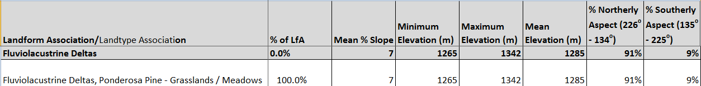

Climate:
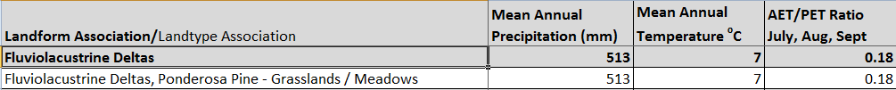

The ratio of Actual Evapotranspiration to Potential Evapotranspiration (AET/PET) is used as a broad-scale indicator of potential drought stress. We obtained modeled actual and potential evapotranspiration datasets from the Numerical Terradynamic Simulation Group at the University of Montana (http://www.ntsg.umt.edu/project/mod16) for a 30 year climate average. AET/PET ratio in the table above is based on a scale of zero to one. A value closer to 1 means the vegetation is transpiring close to its potential. A value farther from 1means that the Actual Evapotranspiration is below potential based on this climatic zone (Ringo, et. al. 2016 in draft).

