Eastern Cascades Faulted Glaciated Volcanoes
Volcanoes are edifies, typically conical in shape, with a central summit vent that erupts effusive magmatic material as ash, cinder, blocks and or lava that accumulates and build up the landform.
Landform Association – Faulted Glaciated Volcanoes:
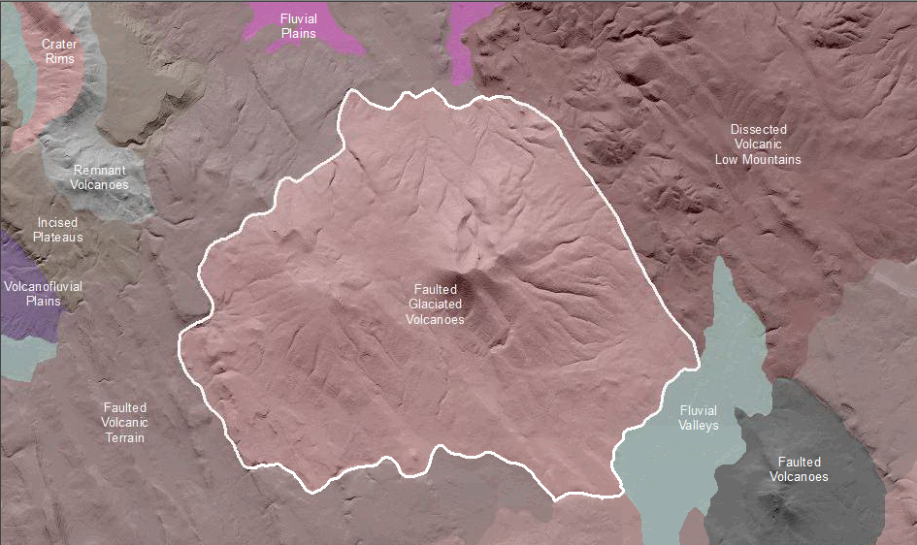

Faulted Glaciated Volcanoes are volcanoes with evidence of past glaciation and faulting. Along the volcanic peaks and ridges there are indicators of past glacial action. Though marred by degradation, the terrain appears glacially scoured with cirque basins, icefields, and U-shaped valleys. Since the cessation of glaciation in these areas, however, surface, mass wasting (shallow rapid or deep seated earthflow, rockfall, etc.) or fluvial erosion processes have dominated and masked much of the glacial signature of the mid to lower slopes. These volcanoes are cut by faults leaving a series of fault scarps that displace bedrock blocks and divert former stream channels to zig-zag courses. Soils are thin to absent om the rocky slopes and thick and rocky along lower (footslope, toeslope) slope positions. Soil taxa are typically Andisols, Alfisos and Mollisols.
This Landform Association has a limited spatial extent on National Forest System Lands.

Landtype Associations: Landtype Associations are formed by intersecting vegetation series or groups of vegetation series with Landform Associations.

Topography:
The following tables represent the average conditions for the Landform Association. Only lands within and adjacent to National Forest System Lands were mapped by this project. The entire EPA Level III Ecoregion is not covered by this mapping.

The percent of Landform Association (% of LfA) in bold in the table below refers to the percent of the Ecoregion represented by that Landform Association. The (% of LfA) numbers not in bold in the table below refer to the percent of each Landtype Association within the Landform Associations.

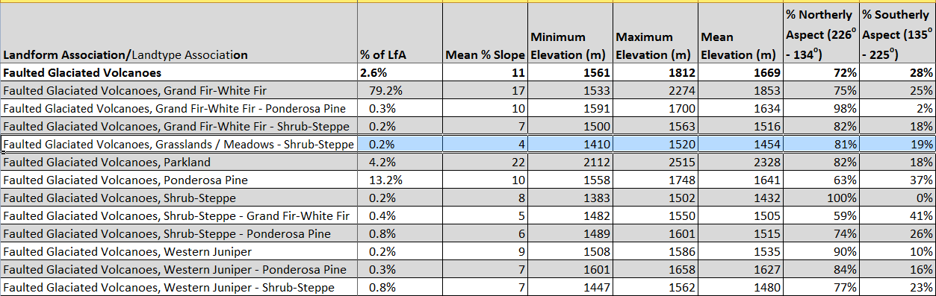

Climate:
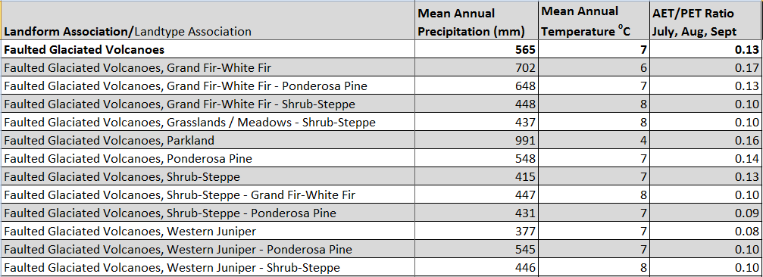
The ratio of Actual Evapotranspiration to Potential Evapotranspiration (AET/PET) is used as a broad-scale indicator of potential drought stress. We obtained modeled actual and potential evapotranspiration datasets from the Numerical Terradynamic Simulation Group at the University of Montana (http://www.ntsg.umt.edu/project/mod16) for a 30 year climate average. AET/PET ratio in the table above is based on a scale of zero to one. A value closer to 1 means the vegetation is transpiring close to its potential. A value farther from 1means that the Actual Evapotranspiration is below potential based on this climatic zone (Ringo, et. al. 2016 in draft).

