Eastern Cascades Glaciated Volcanoes (Mazama)
Volcanoes are edifies, typically conical in shape, with a central summit vent that erupts effusive magmatic material as ash, cinder, blocks and or lava that accumulates and build up the landform.
Landform Association – Glaciated Volcanoes (Mazama):
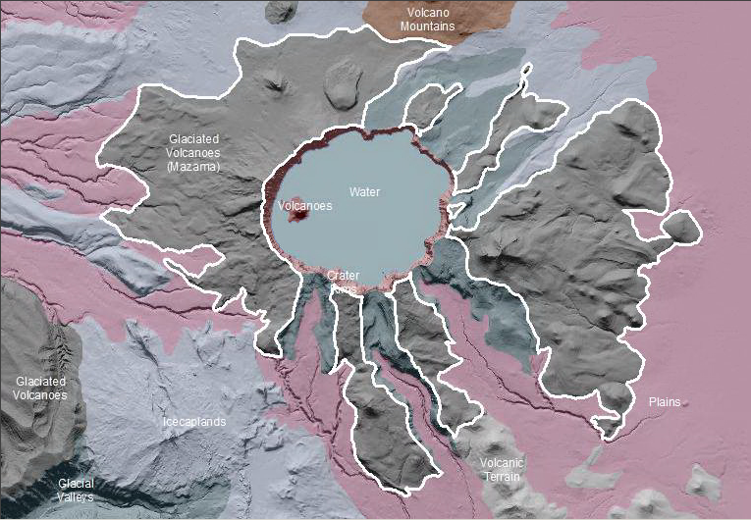

Glaciated Volcanoes (Mazama) are remnant ramparts of Mt. Mazama Volcano which have been shaped by both past glaciers and more recent geomorphic processes. Along peaks and ridges there are indicators of past glacial action. The terrain is locally glacially scoured, with hanging valleys, cirque basins, icefields, and U-shaped. The ramparts of the Mt Mazama Volcano and satellite volcanoes are blanketed with pumiceous tephra and eruptive debris from the volcano’s eruption and collapse. In addition to the eruption, erosion and degradation of this landscape have muted the late glacial and earlier glacial landforms in this mountainous area. Deep incision of the tephra and subsequent glacial deposits has developed narrow, slot canyons and impressive erosional features. Extant deposits and tephra blanket has developed Andisols soil taxa.
This Landform Association is rare on National Forest System Lands.

Landtype Associations: Landtype Associations are formed by intersecting vegetation series or groups of vegetation series with Landform Associations.

Topography:
The following tables represent the average conditions for the Landform Association. Only lands within and adjacent to National Forest System Lands were mapped by this project. The entire EPA Level III Ecoregion is not covered by this mapping.

The percent of Landform Association (% of LfA) in bold in the table below refers to the percent of the Ecoregion represented by that Landform Association. The (% of LfA) numbers not in bold in the table below refer to the percent of each Landtype Association within the Landform Associations.

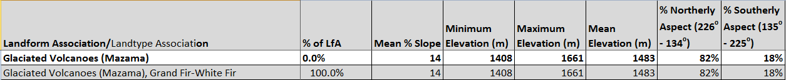

Climate:
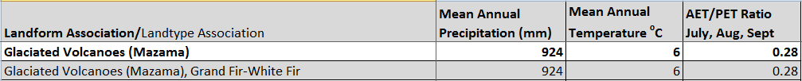

The ratio of Actual Evapotranspiration to Potential Evapotranspiration (AET/PET) is used as a broad-scale indicator of potential drought stress. We obtained modeled actual and potential evapotranspiration datasets from the Numerical Terradynamic Simulation Group at the University of Montana (http://www.ntsg.umt.edu/project/mod16) for a 30 year climate average. AET/PET ratio in the table above is based on a scale of zero to one. A value closer to 1 means the vegetation is transpiring close to its potential. A value farther from 1means that the Actual Evapotranspiration is below potential based on this climatic zone (Ringo, et. al. 2016 in draft).

