North Cascades Glacial Volcanoes
Volcanoes are edifies, typically conical in shape, with a central summit vent that erupts effusive magmatic material as ash, cinder, blocks and or lava that accumulates and build up the landform.
Landform Association – Glacial Volcanoes:
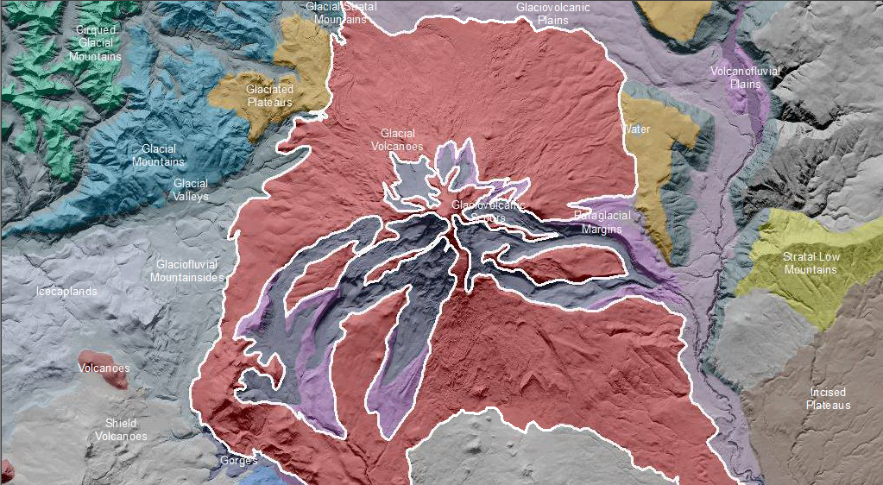

Glacial Volcanoes are volcanoes that have been shaped by present and past glaciers. These are the highest mountain peaks in the Pacific Northwest. Active glaciers are still present within this map unit, as well as icecaps and permanent snowfields. The terrain is glacially scoured, U-shaped valleys and moraines.
A limited variety of soil types are present on Glacial Volcanoes Landform Associations. Soils range from shallow soils to rock or exposed rock sediments which are perched on the sides of these volcanic peaks. Fresh, unconsolidated glacial deposits have been exposed by the recession of glaciers and are subject to rapid erosion during rain on snow events. Soil taxa include Entisols, Andisols, Inceptisols and Spodosols.
This Landform Association is of limited spatial extent on National Forest System Lands.

Landtype Associations: Landtype Associations are formed by intersecting vegetation series or groups of vegetation series with Landform Associations.

Topography:
The following tables represent the average conditions for the Landform Association. Only lands within and adjacent to National Forest System Lands were mapped by this project. The entire EPA Level III Ecoregion is not covered by this mapping.

The percent of Landform Association (% of LfA) in bold in the table below refers to the percent of the Ecoregion represented by that Landform Association. The (% of LfA) numbers not in bold in the table below refer to the percent of each Landtype Association within the Landform Association.
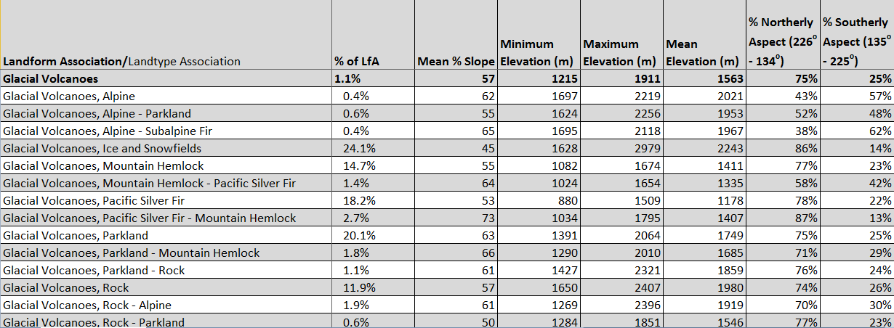

Climate:
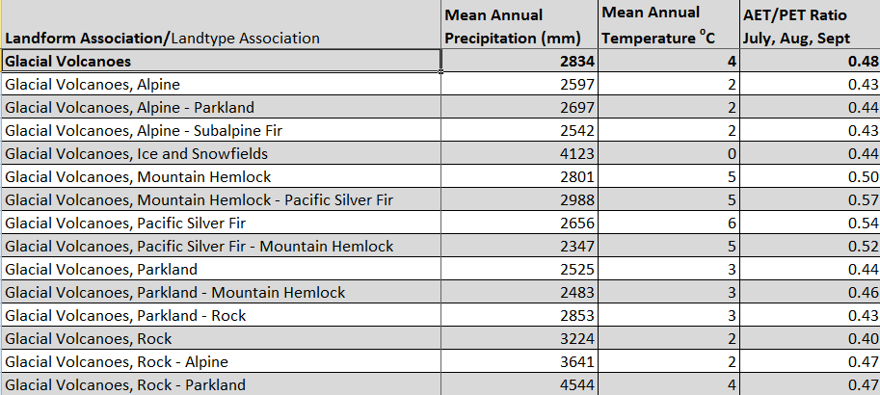

The ratio of Actual Evapotranspiration to Potential Evapotranspiration (AET/PET) is used as a broad-scale indicator of potential drought stress. We obtained modeled actual and potential evapotranspiration datasets from the Numerical Terradynamic Simulation Group at the University of Montana (http://www.ntsg.umt.edu/project/mod16) for a 30 year climate average. AET/PET ratio in the table above is based on a scale of zero to one. A value closer to 1 means the vegetation is transpiring close to its potential. A value farther from 1means that the Actual Evapotranspiration is below potential based on this climatic zone (Ringo, et. al. 2016 in draft).

