Northern Rockies Alpine Basins
Terrain Class: Valley (a) Any low-lying land bordered by higher ground; esp. an elongate, relatively large, gently sloping depression of the Earth's surface, commonly situated between two mountains or between ranges of hills or mountains, and often containing a stream with an outlet. It is usually developed by stream erosion, but may be formed by faulting. (b) A broad area of generally flat land extending inland for a considerable distance, drained or watered by a large river and its tributaries; a river basin. (Bates and Jackson, 1995)

Landform Association: Alpine Basins
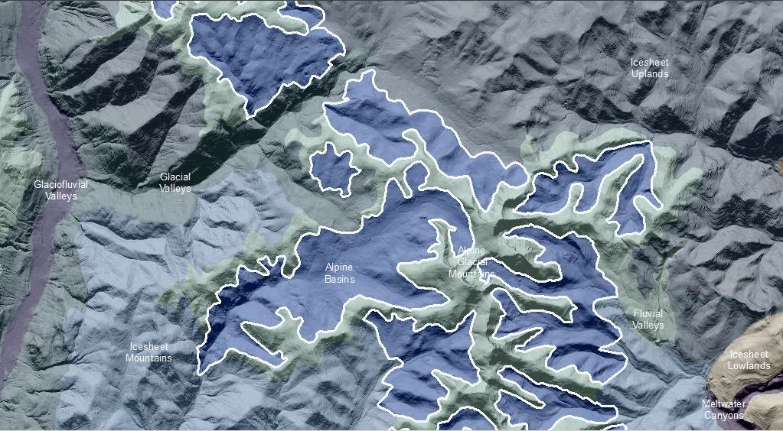

Alpine Basins are cirque basins and glacial valleys emanating from the Alpine Glacial Mountains of the eastern North Cascade Range and the Columbia Mountains of the Northern Rocky Mountain Ecoregion (Kettle River Range and Selkirk Mountains) that stood above the maximal extent of the Cordilleran Icesheet. These basins formed as a result of alpine glaciers on the high mountain slopes above the level of continental glaciation. The Alpine Basins are cirque features and include semi-circular bowl-like excavation in hanging valleys or at the head of a valley. An aerial view of a cirque or alpine basin shows a horseshoe like shape with the open end of the shoe pointing away from the steep headwall and surrounding side slopes. This open end of the shoe is a raised threshold often supplemented by a recessional moraine. The closed depression of the cirque frequently hosts a meadow, lake or tarn. These features often have recessional moraines damming their basins. Since these are high elevation and northern latitudes cirques, the aspect can be to any point of the compass. These basins host relic boreal plant species. In addition to Sposols and Andisols, there is a potential for Gelisol soil taxa to be found here.
This Landform Association has a limited spatial extent on National Forest System Lands.

Landtype Associations: Landtype Associations are formed by intersecting vegetation series or groups of vegetation series with Landform Associations.
Topography:
The following tables represent the average conditions for the Landform Association. Only lands within and adjacent to National Forest System Lands were mapped by this project. The entire EPA Level III Ecoregion is not covered by this mapping.

The percent of Landform Association (% of LfA) in bold in the table below refers to the percent of the Ecoregion represented by that Landform Association. The (% of LfA) numbers not in bold in the table below refer to the percent of each Landtype Association within the Landform Association.
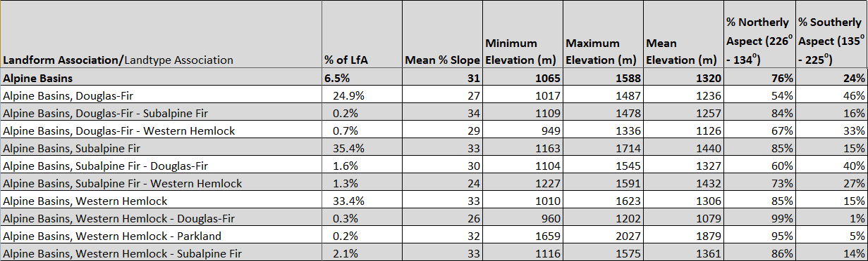

Climate:
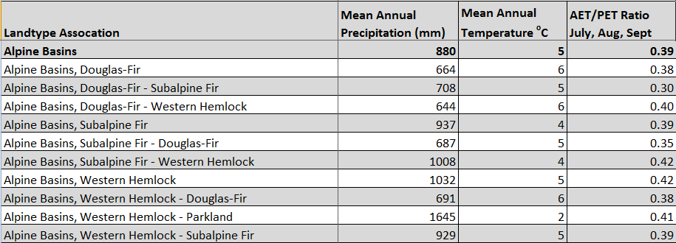
The ratio of Actual Evapotranspiration to Potential Evapotranspiration (AET/PET) is used as a broad-scale indicator of potential drought stress. We obtained modeled actual and potential evapotranspiration datasets from the Numerical Terradynamic Simulation Group at the University of Montana (http://www.ntsg.umt.edu/project/mod16) for a 30 year climate average. AET/PET ratio in the table above is based on a scale of zero to one. A value closer to 1 means the vegetation is transpiring close to its potential. A value farther from 1means that the Actual Evapotranspiration is below potential based on this climatic zone (Ringo, et. al. 2016 in draft).

