Northern Rockies Glacial Valleys
Valley [Landscape Term] (a) Any low-lying land bordered by higher ground; esp. an elongate, relatively large, gently sloping depression of the Earth's surface, commonly situated between two mountains or between ranges of hills or mountains, and often containing a stream with an outlet. It is usually developed by stream erosion, but may be formed by faulting. (b) A broad area of generally flat land extending inland for a considerable distance, drained or watered by a large river and its tributaries; a river basin. (Bates and Jackson, 1995)

Landform Association:
Glacial Valleys
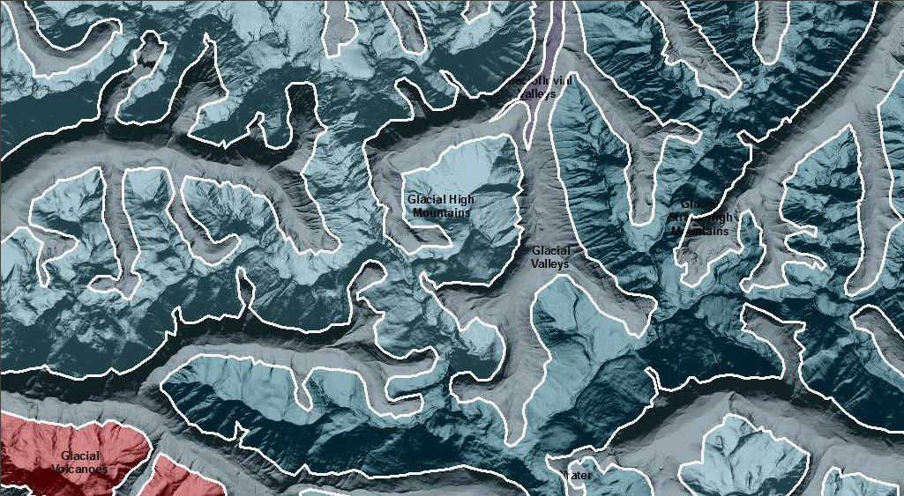

Glacial Valleys are the U-shaped, ice-covered valley segments in glacial and glaciated areas. They include both the glacial valley bottom and sideslopes of the glacial valley wall. Often the landform is too narrow at this scale of mapping to differentiate the bottom as in Glacial Valley Bottoms from the wall sections themselves. The sideslopes accumulate the basal and lateral till of the valley glacier. The area experienced immediate post glacial redistribution of valley side till through colluvial deposition, debris flows, and sheet flow with deposition onto the valley floor. Many areas of the valley walls are exposed to bedrock as a result. There are pockets of lateral moraines with fluvial deposits between them. Seeps and springs emerge in the colluvial material and associated with till deposits.
This Landform Association has an abundant spatial extent on National Forest System Lands.

Landtype Associations: Landtype Associations are formed by intersecting vegetation series or groups of vegetation series with Landform Associations.

Topography:
The following tables represent the average conditions for the Landform Association. Only lands within and adjacent to National Forest System Lands were mapped by this project. The entire EPA Level III Ecoregion is not covered by this mapping.

The percent of Landform Association (% of LfA) in bold in the table below refers to the percent of the Ecoregion represented by that Landform Association. The (% of LfA) numbers not in bold in the table below refer to the percent of each Landtype Association within the Landform Association.

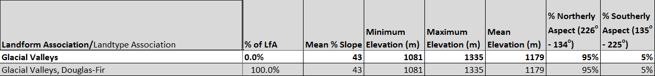

Climate:
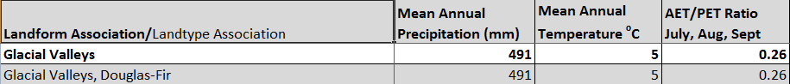

The ratio of Actual Evapotranspiration to Potential Evapotranspiration (AET/PET) is used as a broad-scale indicator of potential drought stress. We obtained modeled actual and potential evapotranspiration datasets from the Numerical Terradynamic Simulation Group at the University of Montana (http://www.ntsg.umt.edu/project/mod16) for a 30 year climate average. AET/PET ratio in the table above is based on a scale of zero to one. A value closer to 1 means the vegetation is transpiring close to its potential. A value farther from 1means that the Actual Evapotranspiration is below potential based on this climatic zone (Ringo, et. al. 2016 in draft).

