Puget Lowlands Icesheet Uplands
Terrain Class: Mountains - No one process responsible for construction of mountains. They can be uplifted, tectonic, subduction of plates, folding, uplift, up and down warping of the mantle, inflation of molten lower crustal (batholiths), etc. Erosion of mountain systems occurs over time. The rate of erosion is dependent on the geomorphic process, the underlying rock structure, and the climate, including both freeze thaw and the amount and intensity of precipitation and runoff. Mountains are further defined and distinguished based on morphology, including the pattern and density of drainages, depth of drainages, overall morphology of the area between the drainages, evidence of a strong imprint of a surficial process such as glaciation, and presence of visible underlying rock structure.
Mountains have simple to very complex forms that have arisen due to inherited rock structure, rock history, and are the net result of local to regional spatial scales of competing rates of upbuilding/uplift and downgrading/erosion. Mountains will have an inherited history from weathering and degradation of the underlying stack of earth materials that forms them. Vegetation, habitat, water interception, collection and transport will share a similar history in the same type of uplift and rock.

Landform Association: Icesheet Uplands
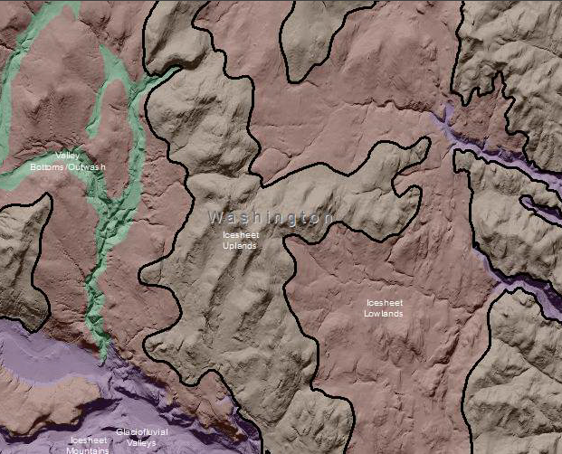

Icesheet Uplands are an extensive area of higher land that was scoured by the Cordilleran Icesheet. Icesheet Uplands do not have glacial valleys mapped in them. They tend to be in a lower landscape position than Icesheet Mountains. Icesheet Upland occur on the old piedmont plains that fronted the Icesheet Mountains, typically where the original glacial valleys under alpine glacial influence ended. They may have old moraine features. Icesheet Uplands are low relief, undulating terrain that have quite a bit of compacted till in places from the Cordilleran Icesheet. Water will stay on landscape due to low slope angles. The drainage networks may not be fully integrated; as a result, some areas will be moist. In pockets there may be lakes and ponds, soils may not be so drought prone. There may be drainages with no outlets that are filled with till deposition.

This Landform Association has a common spatial extent on National Forest System Lands.

Landtype Associations: Landtype Associations are formed by intersecting vegetation series or groups of vegetation series with Landform Associations.
Topography:
The following tables represent the average conditions for the Landform Association. Only lands within and adjacent to National Forest System Lands were mapped by this project. The entire EPA Level III Ecoregion is not covered by this mapping.

The percent of Landform Association (% of LfA) in bold in the table below refers to the percent of the Ecoregion represented by that Landform Association. The (% of LfA) numbers not in bold in the table below refer to the percent of each Landtype Association within the Landform Association.
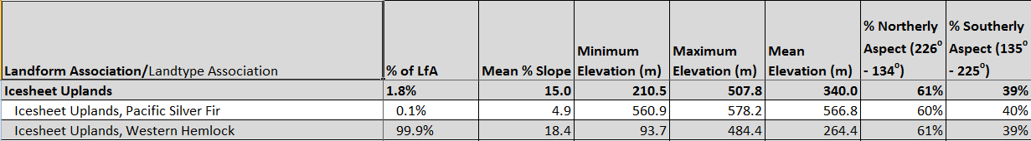

Climate:
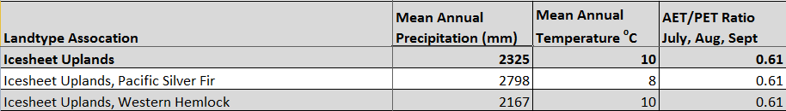

The ratio of Actual Evapotranspiration to Potential Evapotranspiration (AET/PET) is used as a broad-scale indicator of potential drought stress. We obtained modeled actual and potential evapotranspiration datasets from the Numerical Terradynamic Simulation Group at the University of Montana (http://www.ntsg.umt.edu/project/mod16) for a 30 year climate average. AET/PET ratio in the table above is based on a scale of zero to one. A value closer to 1 means the vegetation is transpiring close to its potential. A value farther from 1means that the Actual Evapotranspiration is below potential based on this climatic zone (Ringo, et. al. 2016 in draft).

