**Walter Climate Diagram Tool Instructions**

**Summary**: Monthly average temperature and precipitation data is available in raster format for the following time periods: a) Daymet normal (average over the years 1950 – 2000), and from the NOAA GFDL CM3 model there are data for b) future prediction for 2030, c) future prediction for 2050, and d) future prediction for 2070. Altogether that makes 96 raster data layers. The Walter Climate Diagram Tool iterates through the 96 raster data layers to extract the monthly mean temperature and precipitation for each time period for a user defined area of interest. The extracted information is then consolidated into a single Microsoft Excel table that can be imported into a Microsoft Excel template to produce graphs comparing monthly temperature and precipitation for each time period.

**Introduction:** The Walter Climate Diagram (Walter 19851) was developed to compare climates among different geographic locations. Here we use the diagrams to compare climates projected for different periods in the future. The concept and methods for doing this were developed by Michael Jennings, an ecologist with the U.S. Forest Service Blue Mountains Ecology and Forest Health Programs in La Grande Oregon ([michaeldjennings@fs.fed.us](mailto:michaeldjennings@fs.fed.us)). The scripting and automation provided in the tool were developed by Andrew Stratton, a geospatial systems specialist with the U.S. Forest Service's Region 6 Data Resources Management Program ([astratton@fs.fed.us](mailto:astratton@fs.fed.us)).

1Walter, H. (1985). Vegetation of the earth and ecological systems of the geo-biosphere. Springer-Verlag, translation, 3rd ed.

**Part 1: Running the Walter Climate Diagram Tool**

1. To use the tool first use ArcCatalog to navigate to the folder containing the WalterClimateDiagrams_Tool_WGS84_v2 toolbox.

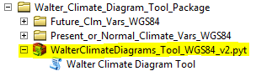

1. To open the tool, double click the script



1. The tool opens and the user will see that 5 parameters need to be filled out before running the tool.

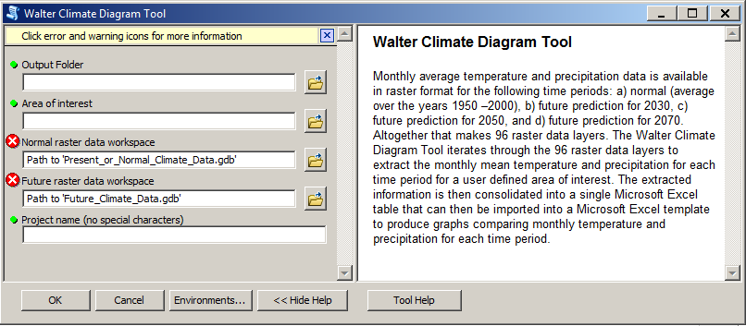

1. Make sure the Show Help button has been selected in order to display a description of each parameter. Populate each parameter by following the Help instructions. All parameters are required.
   1. Output Folder…The output folder where the output Excel file will be saved.
   2. Area of Interest… A feature class or shapefile polygon that defines the area of interest.
   3. Normal raster data workspace should look similar to the image below.



* 1. Future raster data workspace should look similar to the image below.



* 1. Project name…The name of the Microsoft Excel spreadsheet.

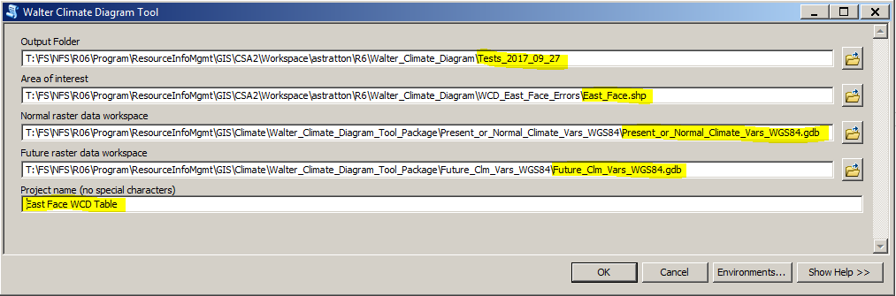

1. Running the script produces a Microsoft Excel table saved to the specified folder.

**Part 2: Converting the exported Excel table data into useful information**

There are a few steps to take to add the data to the Excel template that does the unit conversions and creates graphs of the data. You will be working with two Excel files, the **template** and the **export table** from the Walter Climate Diagram Tool.

Steps 1 – 3 work with the **template**.

1. Open the template by double clicking on it.



1. When an Excel template opens it will automatically receive a new name (the number ‘1’ is added to the end of the file name). If you wish to change the file name, click on File…Save As and save the file with a new name in your project folder.
2. At the bottom of the page you will see three worksheet tabs: Data, Pivot, and Template. Make sure you are in the Data Worksheet.



Steps 4 – 8 work with the **export table**. This table is exported from the ArcGIS tool.

1. Open your output Excel file by double clicking on it.
2. 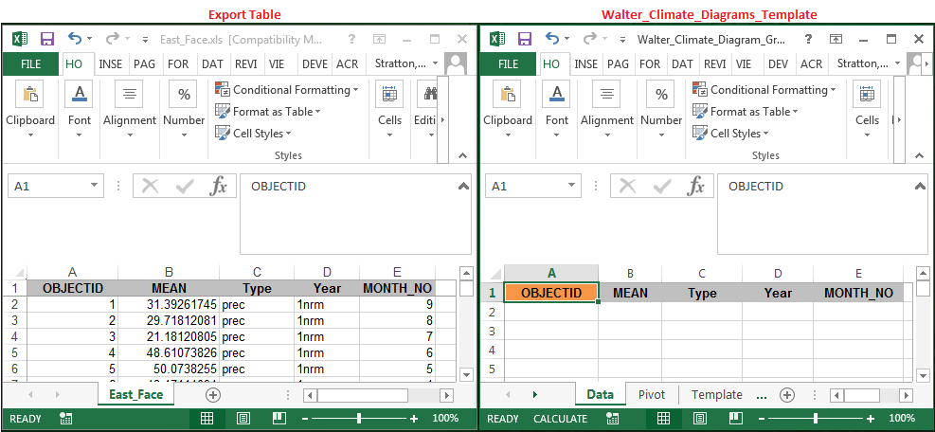There are now two excel files open. You may want to arrange them on your screen side-by-side.
3. When the export table file is open you will see the climate data arranged in 5 columns.

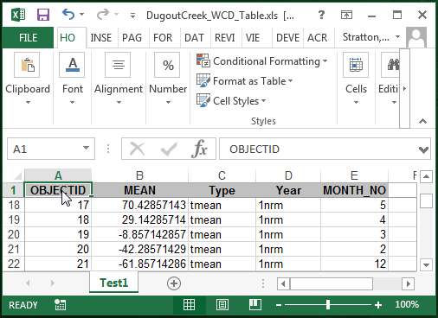

1. Click on the OBJECTID cell and press Ctrl/Shift/End to select all of the data (including the headings). The selection will include columns A – E, rows 1 – 97.

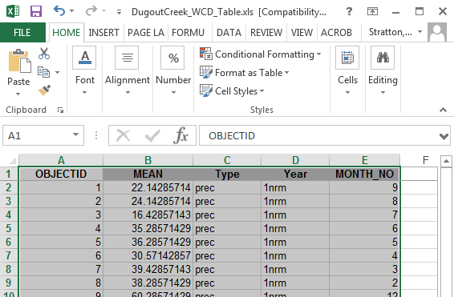

1. Once the data have been selected, right click inside the selection area and copy.

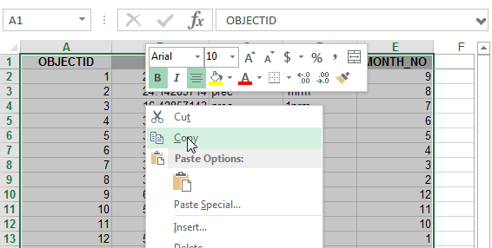

Steps 9 – 15 take place on your saved copy of the **template**.

1. Right click on the orange **OBJECTID** cell (cell A1) and select Paste to paste your data into the template. The first paste option Paste (P) will work fine.

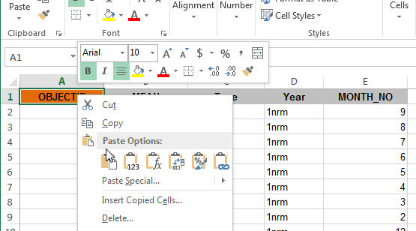

1. Once the data have been added to the Data worksheet, a macro instructs the pivot sheet to refresh.

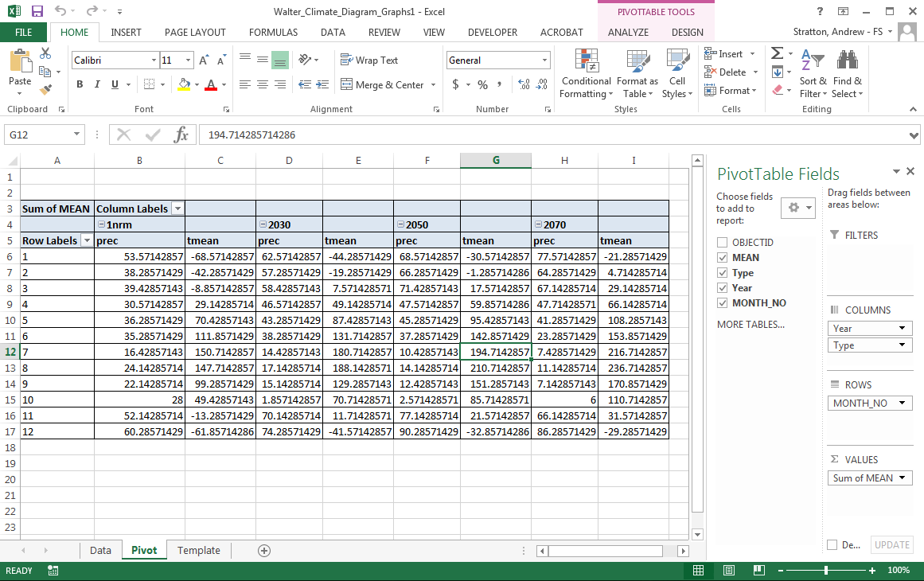

1. Click on the Template worksheet to view the updated tables, conversion to English values, and line graphs.



1. On the Template worksheet you will see one green cell called Name of Area. Updating the text in this cell will update the Name of Area text in the line graphs.



1. The configuration of a Walter Climate Diagram calls for 50°F on the Temperature axis (primary axis) to line up with 0.787” on the Precipitation axis (secondary axis). To make this happen, the Template sheet uses a macro to set the minimum and maximum values for the Temperature and Precipitation axes. That value are set as follows:
2. Temp max – maximum value rounded up to the nearest multiple of 5
3. Temp min – minimum value rounded down to the nearest multiple of 5
4. Precip max – maximum value rounded up to the nearest multiple of 1
5. Precip min – calculated from the formula below where T is temperature and P is precipitation:
$$\left[\left(\frac{(50-Tmin)}{(Tmax-50)}×(Pmax-0.787) \right)-0.787\right]× -1=Pmin$$

6. It’s a good idea to check that the minimum and maximum values of the line graphs match the Values for axis adjustments table:

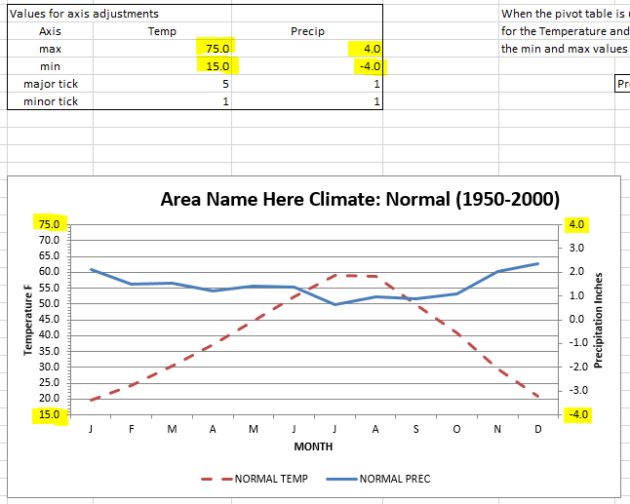

1. If the axis values to not match the Values for axis adjustments table, manually refresh the settings by first clicking on the min or max value cell (C41, C42, D41, or D42), then clicking at the end of the formula bar, and pressing Enter. Repeat for each of the four cells.

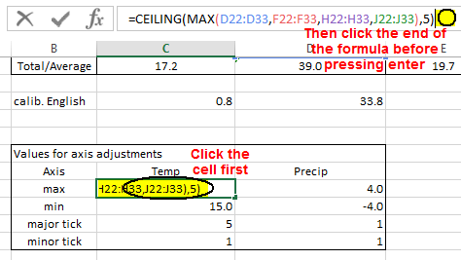

Contact:

|  |  |  |  |  |  |  |
| --- | --- | --- | --- | --- | --- | --- |
| Forest Service Shield | |  | | --- | | **Andrew Stratton  Geospatial Systems Specialist** | | **Forest Service**  **Region 6 Data Resources Managment**  **Customer Service Area 2** | | **p: 541-225-6367** [**astratton@fs.fed.us**](mailto:astratton@fs.fed.us) | | 3106 Pierce Parkway Springfield, OR 97477 [www.fs.fed.us](http://www.fs.fed.us/)  [USDA Logo](http://usda.gov/)[Forest Service Twitter](https://twitter.com/forestservice)[USDA Facebook](https://www.facebook.com/pages/US-Forest-Service/1431984283714112) | | **Caring for the land and serving people**  **For information and help with GIS and mapping:** [**R6 GIS User Support Center**](https://ems-team.usda.gov/sites/fs-r06-gis-usc/SitePages/Home.aspx) | |