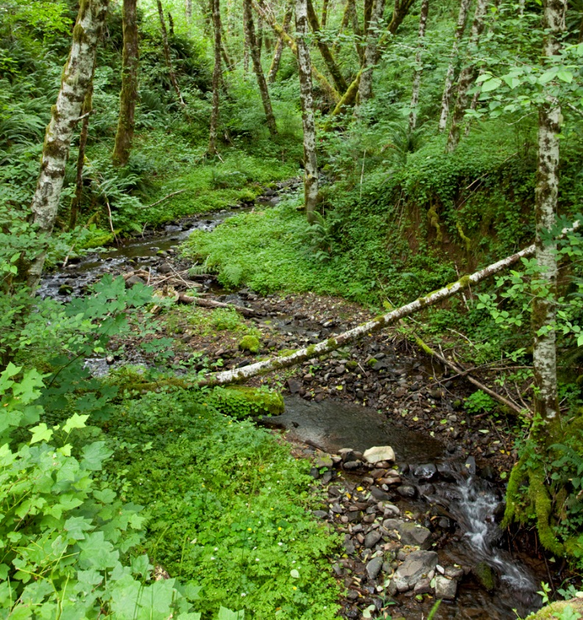 | Summer Low Flows in  Western Oregon:  Processes, Trends, Uncertainties, and Management Implications  April 4, 2018  Corvallis Forestry Sciences Lab, Room 20, Corvallis, OR  Organized by the Pacific Northwest Research Station, the Bureau of Land Management, Weyerhaeuser Company, and National Council for Stream and Air Improvement

Workshop Goal: Explore the current science of summer low stream flows in western Oregon, and identify/prioritize gaps in our knowledge on the topic.
Target Audience: Forest managers of state, private, and federal lands interested in furthering their understanding of low summer flow processes and trends and being part of a dialogue on this issue.
Location: Corvallis Forestry Sciences Lab, 3200 SW Jefferson Way, Corvallis, OR
Please RSVP to: cfriesen@fs.fed.us by March 15, 2018


Agenda

Time | Topic | Speaker
9:00 - 9:05 | Welcome! Outline of the day | Cheryl Friesen, Science Liaison, USFS
9:05 – 9:15 | Setting the Stage: The meaning and use of “Best Available Science” – what makes stream flow an issue? | Mike Brown, Soil, Water & Air Program Lead, BLM Oregon State Office, and Johan Hogervorst, Hydrologist, Willamette NF Forest

Summer Low Flows in Western Oregon:
Agenda Continued
Time | Topic | Speaker
9:15 – 9:25 | Introduction to summer low flows: organizing principles and terminology. | Maryanne Reiter, Hydrologist, Weyerhaeuser Co.
9:25 – 9:45 | Climate change projections and potential effects on stream flow. | Kathie Dello, Associate Director, Oregon Climate Change Research Institute
9:45 – 10:05 | Evapotranspiration variability across dominant ecosystems in the PNW. | Hyojung Kwon, Research Associate, OSU
10:05 – 10:25 | How forest management influences interaction between vegetation and water. | Klaus Puettmann, Silviculturist, OSU
10:25 – 10:40 | Break
10:40 – 11:00 | Subsurface flow paths and low summer flows: influence of channel geomorphology. | Steve Wondzell, Research Ecologist, USFS PNW Research Station
11:00 – 11:30 | Streamflow trends from long term data in the Western Cascades. | Julia Jones, Geography Professor, Oregon State University
11:30 – 12:00 | Streamflow trends from long term data in the Coast Range, northern California. | Elizabeth Keppeler, Hydrologist, or Joe Wagenbrenner, Research Hydrologist, USFS PSW Research Station
12:00 – 12:30 | Lunch: bring donation for catered pizza OR bring your own food.
12:30 – 12:50 | Effects of drought and regional low flows. | Charlie Luce, Research Hydrologist, USFS Rocky Mountain Research Station
12:50 – 1:10 | Biological response to low stream flows. | Brooke Penaluna, Research Fisheries Biologist, USFS PNW Research Station
1:10 – 1:30 | Revisiting the water budget and forest management: overview of questions posed by managers (we will be asking attendees to send questions in advance). | Sherri Johnson, Research Ecologist, USFS PNW Research Station
1:30 – 3:30 | Facilitated discussion on using the best available science on summer low flows to link processes, issues of scale, uncertainties, data gaps, and management implications. | Cheryl Friesen, USFS Science Liaison and Ashley Coble, NCASI

