Huckleberry Treatment Monitoring Protocol
March 13, 2020

I. PROJECT OBJECTIVES
Huckleberries are an important fruit for wildlife, cultural, and recreation resources. Huckleberry productivity has been reported as declining in the past due to land management and other factors (Minore 1972). With recognition of its importance, huckleberry enhancement is becoming included in forest management direction. While many factors contribute to huckleberry productivity, there have been observations that fruit production increases with lower canopy cover. Anzinger (2002) found that big leaf huckleberry (Vaccinium membranaceum) produced more fruit with decreasing canopy cover, and Minore (1984) found an open canopy coupled with other treatments had positive effects on big huckleberry fruit production. Further work is needed to determine the best forest management treatments to enhance huckleberries.

In order to enhance huckleberry habitat and fruit production, the Mount Hood National Forest is planning treatments in the 7,300-acre Waucoma planning area. The treatment prescriptions may consist of variable density thinning, shelterwood, and intermediate thinning that would produce a desired condition of approximately 30% canopy cover.

Our monitoring objective for this project is:

- To measure the effects of the prescribed treatments on big huckleberry (Vaccinium membranaceum) productivity in terms of percent cover and fruit production in the project area.

II.SAMPLING DESIGN

Plot measurements were taken in treatment and control areas. Treatment units were selected based on their current and future potential to maintain and enhance the presence of big leaf huckleberry understory at the landscape scale across the project area. Control areas are nearby stands that reflect desired future condition of target canopy cover ranges with huckleberry presence. These were selected with stand evaluation data and Lidar.

Plot selection: up to 5 randomly selected plots were generated in both treatment and control units, area permitting, in ArcGIS software. A distance buffer of 224 feet (150 foot site tree height + 74 foot diameter plot) was added to the internal treatment unit boundary and between plots to reduce stand edge effects and insure independence among plots, respectively. The monitoring project area, unit, and plot location can be found in Figure 1.

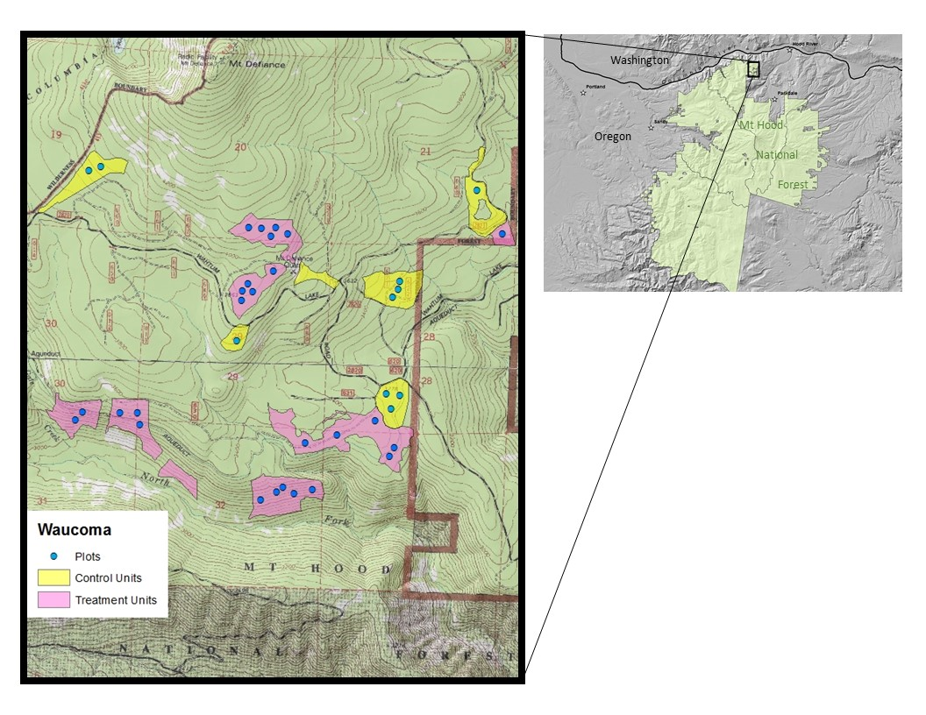
Figure 1. Waucoma huckleberry treatment planning area.

III.PLOT MEASUREMENTS

Plot design is based on the fire effects monitoring (FIREMON) manual (Lutes et al. 2006), with
specific measurements from FIREMON and other sources. We will record plot characteristics using the
plot description (PD, Keane 2006) method, and cover of huckleberry species with the line intercept (LI, Caratti 2006) method. We will also measure overstory canopy cover with the moosehorn densitometer (Garrison, 1949), huckleberry fruit production following Anzinger (2002), and cover of plant species that may compete with huckleberries.

We will use the data forms included in the respective chapters in the FIREMON manual and forms developed specifically for this project. Plots will be circular with an area of 0.1 ac (radius of 37.24 ft/11.35 m). The layout for the individual sampling methods is shown below (Figure 2).

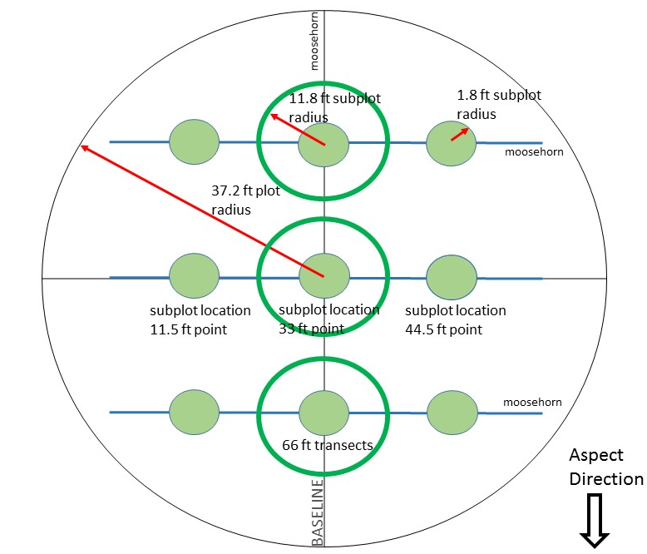

Figure 2. Overall plot layout. Cover of each huckleberry species will be measured along the 3 line intercept transects. Huckleberry fruit production classes will be recorded in the nine 1.8 ft radius subplots. Competitive vegetation cover classes will be recorded in the three 11.8 ft radius subplots. Overstory canopy cover will be measured by moosehorn every 2 ft along the two 66 ft outer transects and the 74.4 ft baseline transect for a total of 100 measure points. The baseline transect follows aspect, and the three 66 ft transects are perpendicular to the aspect direction and parallel to slope contours. The plot center is marked with rebar that has orange flagging attached to it.
Plot Description (PD)
Use Plot Description (PD) Form from the FIREMON manual. Fill out only the fields indicated below.
- required Database Key (header fields)
  - Registration ID: leave blank
  - Project ID: Waucoma Huckleberry
  - Plot: Enter predetermined plot number
  - Date: Enter the date of start of sampling as an eight-digit number in the MM/DD/YYYY
- Organization Information (fields 1-4)
  - Organization Code 1: R06
  - Organization Code 2: MTH
  - Organization Code 3: HRRD
  - Organization Code 4: leave blank
- Plot Information (fields 5-12)
  - Examiner: The name of the crew lead, using up to eight-characters. Use first letter of first name followed by a dot followed by the entire last name (up to the character limit). Use all lower case letters. For example, Smokey Bear would be s.bear and John Smith would be j.smith. Do not include blanks in the text.
  - Units: Circle ‘E’ since we recording data in English units.
  - Plot Radius: Circle ‘ft’ and record 37.24 for the plot radius
  - Plot Width: leave blank
  - Plot type: Circle ‘M’ if plot is within a treatment unit. Circle ‘C’, for control plot.
  - Sampling Event: Enter ‘P1’ for first pre-treatment measurement.
  - FireID: leave blank
  - Metadata ID: leave blank
- Georeferenced Position (fields 13-21)
  - Leave blank
- Biophysical Settings (fields 22-27)
  - Elevation: leave blank – will be extracted from Lidar
  - Plot Aspect: Enter the aspect of the plot in degrees true north.
  - Aspect is the direction the plot is facing. For example, a slope that faces exactly west would have an aspect of 270 degrees true north. Be sure to record the aspect that best represents the macroplot as a whole and not just the point where you are standing. Also, be sure you check your compass reading with your knowledge of the area to be sure that the aspect indicated is really correct. Often, metal on sampling equipment, or iron rebar plot center, can influence the estimation of aspect.
  - Slope: Record the plot slope using the percent scale to the nearest unit. To find the percent slope, aim the clinometer at the eye level of sampler at the other end of the line. Be sure to read the slope off the percent scale in the clinometer. If there is a height difference of the samplers, adjust the height where you are aiming so that the slope reading is accurate. The slope is measured as an average of the uphill and downhill slope from plot center. Be sure the recorded slope reflects the slope of the entire plot and not just the line where you are standing. Slope values should always be positive.
  - Landform: leave blank
  - Vertical Slope Shape: leave blank
  - Horizontal Slope Shape: leave blank
- Surface Fire Behavior Fuel Model (field 66): leave blank
- General Fuel Characteristics (fields 68-70): leave blank

- Digital photos (note that we are not using fields 75-78; just take photos as indicated below)
  - Identifier photograph—a sign with plot number and date in YYYYMMDD format
  - Canopy—stand at the center of the plot and point camera straight up. In the office this file will be labelled the date in YYYYMMDD format, three characters indicating the plot (‘P’ followed by the plot number), and ‘CAN’ for canopy. For example, if the photo for plot 3 is taken on August 29, 2020, the file name would be ‘20200829P03CAN’.
  - Upslope view (horizontal)—From plot center, point camera forward on upslope baseline tape and focus on target 10 ft away. In the office this file will be labelled the date in YYYYMMDD format, three characters indicating the plot (‘P’ followed by the plot number), and ‘U’ for upslope. For example, if the photo for plot 3 is taken on August 29, 2020, the file name would be ‘20200829P03U’.
  - Downslope view (horizontal)—From plot center, point camera forward on downslope baseline tape and focus on target 10 ft away. In the office this file will be labelled the date in YYYYMMDD format, three characters indicating the plot (‘P’ followed by the plot number), and ‘D’ for downslope. For example, if the photo for plot 3 is taken on August 29, 2020, the file name would be ‘20200829P03D’.
  - Sideslope view 1 (horizontal)—From plot center, point camera forward on one side middle transect baseline tape and focus on target 10 ft away. In the office this file will be labelled the date in YYYYMMDD format, three characters indicating the plot (‘P’ followed by the plot number), and ‘S+Azimuth’ of camera direction. For example, if the photo for plot 3 is taken on August 29, 2020, the file name would be ‘20200829P03S[az]’.
  - Sideslope view 2 (horizontal)—From plot center, point camera forward in the opposite direction of the first sideslope photo on the side middle transect baseline tape and focus on target 10 ft away. In the office this file will be labelled the date in YYYYMMDD format, three characters indicating the plot (‘P’ followed by the plot number), and ‘S+Azimuth’ of camera direction. For example, if the photo for plot 3 is taken on August 29, 2020, the file name would be ‘20200829P03S[az]’.
- Plant Associations: Use both Eastside (Simpson, 2007) and Westside (McCain & Diaz, 2002) plant association guides (start with Eastside) to determine correct plant association for each subplot. If due to historical harvesting and planting this becomes difficult, list dominant tree, shrub, and forb species and percent cover on back of FIREMON form.

Understory vegetation measurements (Line intercept (LI))
We will measure cover of big huckleberry using LI. The transects will be laid out perpendicular to the aspect direction. The middle transect centered on plot center and upper and lower transects placed parallel at 18.75 ft spacing as pictured in Figure 1. If the plot is flat, orient transects north-south. A measuring tape that is marked in 10ths and 100ths of feet should be used. Use Line intercept (LI) Form from the FIREMON manual.
- Plot Key: refer to instruction for PD Form above
- Field 1: Number of Transects-Record the total number of transects on the plot (3).
- Field 2: Transect Number-sequential number of the sample transect
- Field 3: Item Code-Record the NRCS Plants species code each huckleberry species found – see field NRCS code cheat sheet.
- Field 4: Status- Plant status—Live, Dead, or Not Applicable. (L, D, NA).
- Field 5: Size Class -Leave Blank
- Field 6: Transect Length 66 ft
- Start. Figures LI 1 – 4. Enter the starting point of each intercept for the plant species along the transect. Record to the nearest 0.1 ft. Proceed from the zero mark on the tape toward the opposite end of the tape and measure the horizontal linear length of each plant that intercepts the line. Read along the uphill edge of the tape. Measure the vertical projection of the vegetation intercepting the tape.
- Stop. Enter the stopping point of each intercept for the plant species along the transect. Record to the nearest 0.1 ft. Gaps within a plant’s canopy less than or equal to 2” are ignored when determining where to stop an individual intercept.
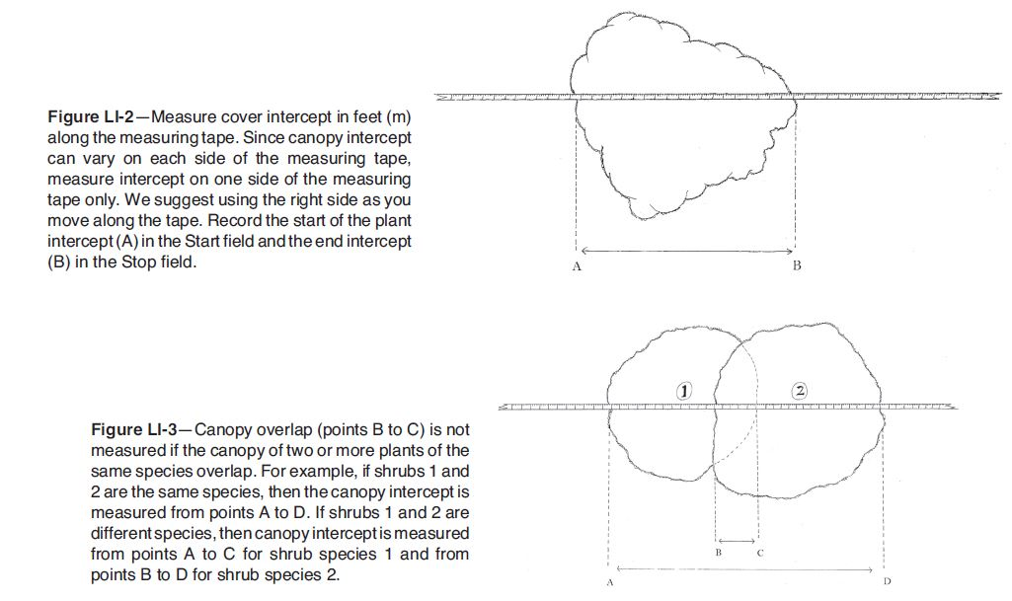
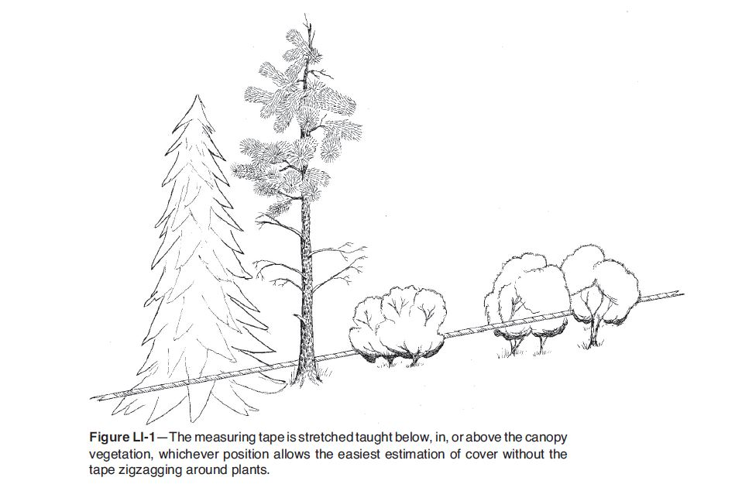
- Height. Figure LI 5. Enter the average height for each plant species at each intercept along the transect. The estimation should be for only the part of the plant that is intercepted by the tape, not the entire plant.

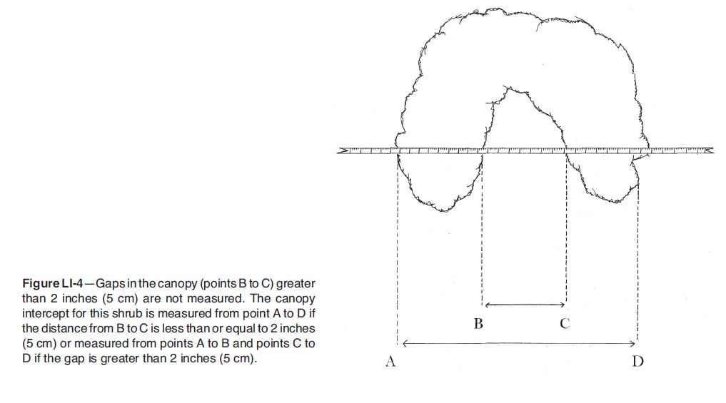

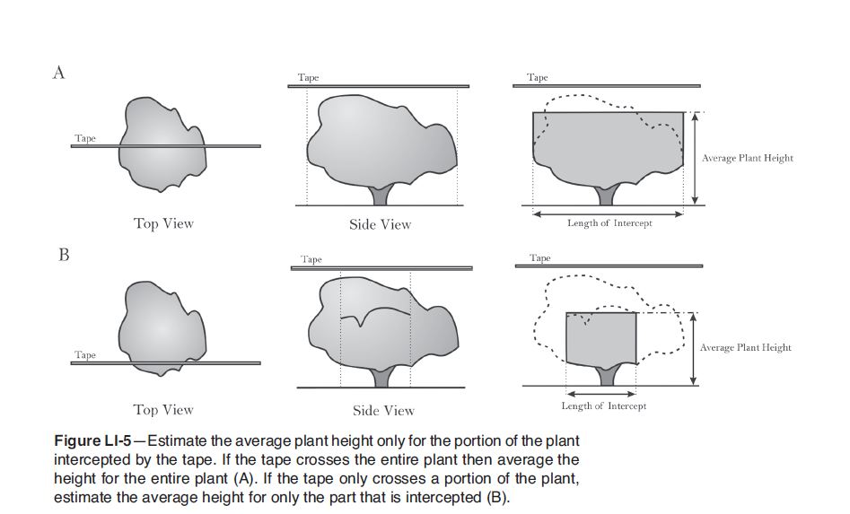

Overstory canopy cover

Record overstory canopy (>6ft) using the moosehorn every 2 ft along the two outer 66 ft transects and 74.4 ft baseline transect illustrated in Figure 1. For the 66 ft transects, record ‘yes’ (for canopy present) or ‘no’, on the custom dataform developed for this project, starting at 2 ft., and at every even-numbered foot marking to the end of the tape. For the baseline transect, stretch a measuring tape from plot center uphill, and then downhill. Each time, record ‘yes’ or ‘no’ starting at 2 ft, and at every even-numbered foot marking up to and including 34 ft. This will yield 100 canopy measurements per plot. If the only plant material contributing cover at a point is due to a broad-leaved, shrubby species such as chinquapin or vine maple, make a note on the data sheet indicating this situation.

Huckleberry fruit production measurements

To measure huckleberry fruit production, record the fruit production class (Table 1) in the 1.8 ft radius subplots pictured in Figure 1. Use the custom dataform developed for this project.

Table 1. Anzinger (2002) Fruit production class definition table.
Fruit Production Class Code | Class Definition
0 | No huckleberry plants in plot
1 | Huckleberry plants in plot, no fruit
2 | Low (< 5 fruits/stem on all stems in plot)
3 | Medium (<5 fruits/stem on most stems in plot, between 5-10 on others)
4 | Medium-high (<10 fruits on most stems in plot, between 10-15 on others)
5 | High (<15 fruits on most stems in plot, between 15-20 on others)
6 | Extra high (>20 fruits on most stems in plot

Competing vegetation measurements

To measure competing vegetation, lump regenerating trees < 6 ft in height, non-huckleberry shrubs, beargrass, and bracken fern into one group and record group cover class code (Table 2; cover class codes from Daubenmire (1959), with the addition of a 0% class). In addition, for each subplot, list select competitive species in order of dominance. Use NRCS plant species codes – see field NRCS code cheat sheet. If an NRCS plant code is not on the cheat sheet, spell out the scientific name. See Fig. 1 for the location of the three subplots for competing vegetation.

Table 2. Cover class code
% Cover Class Code | % Cover Class
0 | 0%
1 | 1 to 5%
2 | 5 to 25%
3 | 25 to 50%
4 | 50 to 75%
5 | 75 to 95%
6 | 95 to 100%

IV. INITIAL DATA ANALYSIS
We will analyze data with appropriate non-parametric statistical methods.

V. LITERATURE CITED

Anzinger, D. 2002. Big Huckleberry (Vaccinium membranaceum), Ecology and Forest
Succession, Mt Hood National Forest and Warm Springs Indian Reservation, Oregon.
Master of Science Thesis, Oregon State University, Corvallis, OR. 121 pages.
Caratti, J.F. 2006. Line Intercept Sampling Method. In D.C. Lutes, R.E. Keane, J.F. Caratti, C.H. Key, N.C. Benson, S. Sutherland, and L.J. Gangi. FIREMON: Fire effects monitoring and inventory system. Gen. Tech. Rep. RMRS-GTR-164-CD. Fort Collins, CO: U.S. Department of Agriculture, Forest Service, Rocky Mountain Research Station.
Daubenmire, R.F. 1959. A canopy cover method of vegetation analysis. Northwest Science 33: 43-46.
Garrison, G.A. 1949. Uses and modifications for the “moosehorn” crown closure estimator.
Journal of Forestry 47(9): 733-735.
Keane, R.E. 2006. Plot Description (PD) Sampling Method. In D.C. Lutes, R.E. Keane, J.F. Caratti, C.H. Key, N.C. Benson, S. Sutherland, and L.J. Gangi. FIREMON: Fire effects monitoring and inventory system. Gen. Tech. Rep. RMRS-GTR-164-CD. Fort Collins, CO: U.S. Department of Agriculture, Forest Service, Rocky Mountain Research Station.
Lutes, D.C., R.E. Keane, J.F. Caratti, C.H. Key, N.C. Benson, S. Sutherland, and L.J. Gangi.
2006. FIREMON: Fire effects monitoring and inventory system. Gen. Tech. Rep. RMRS-
GTR-164-CD. Fort Collins, CO: U.S. Department of Agriculture, Forest Service, Rocky
Mountain Research Station.
McCain, C., and N. Diaz. 2002. Field Guide to the Forested Plant Associations of the Westside
Central Cascades of Northwest Oregon. Portland, OR: USDA Forest Service, Pacific
Northwest Region R6-NR-Ecol-TP-02-02
Minore, D. 1972. The wild huckleberries of Oregon and Washington: A dwindling resource.
USDA Forest Service Research Paper PNW – 143. Portland, OR. Pacific Northwest
Research Station.
Minore, D. 1984. Vaccinium membranaceum berry production seven years after treatment to
reduce overstory tree canopies. Northwest Science: 58(3).
Simpson, M., 2007. Forested plant associations of the Oregon East Cascades. Portland, OR:
USDA Forest Service Pacific Northwest Region. R6-NR-ECOL-TP-03-2007.

VI. EQUIPMENT LIST:

- 1 Clipboard
- Pencils
- Sharpies
- AA Batteries (for GarminGPS, make sure Radio and Camera are fully charged)
- 1 radio
- Data sheets
- Protocols
- At least 1 set of FIREMON chapters (PD, LI)
- 3 100’ tapes (in .1/ft)
- 1 hammer
- Clinometer
- Moosehorn
- 2 compasses
- 1 rebar or stake per plot
- 4 survey pins
- 2 binder clips
- Camera/phone
- Laminated Paper for marking plot #/date
- Flagging
- 1 plant ID reference
- 1 yardstick/pole
- 1 calculator
- Chord (1.8ft)
- Pin flags
- Logger tape
- Eastside and Westside Plant Association Guides

Plot Center:
- clinometer
- compass
- GPS unit
- hammer
- rebar
- survey pin
- camera/paper for plot #/date
- flagging
- plant associations guides
Huckleberry Subplots/Canopy Points:
- 1 100’ tape
- Chord or hula hoop (for huckleberry subplot, 1.8 ft long for radius)
- Pocket calculator
- Pin flags
- 1-2 Logger tape
- 1 survey pin
- Moosehorn
Line intercept:
- Plant ID reference
- 2 100 ‘ tapes
- 2 Survey pins
- Binder clips
- Yardstick/pole

